Bash + ChatGPT Learning Activity
Goal
You already have the list of Bash commands and script structures required for the Organizer Assignment. In this activity, you will use ChatGPT as your tutor to learn how each command works, with examples.
You will:
- Take one command or structure at a time.
- Ask ChatGPT:
- <command here>
- How does this work? Show me an example.
- Read ChatGPT’s explanation and example.
- Try the example in Git Bash inside VSCode.
- Record your own notes about what happened.
- This needs to be placed into OneNote in its own page that will be handed in.
Bash Commands to Explore
File and Folder Management
- Mkdir – make directory. Creates a new directory
- 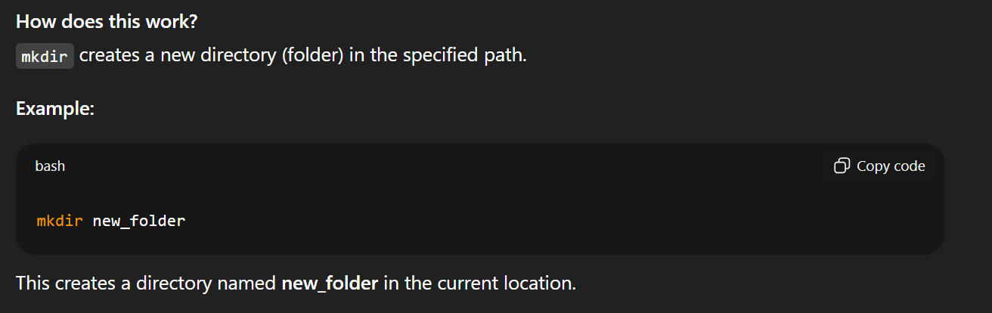
- Cd – change directory
- 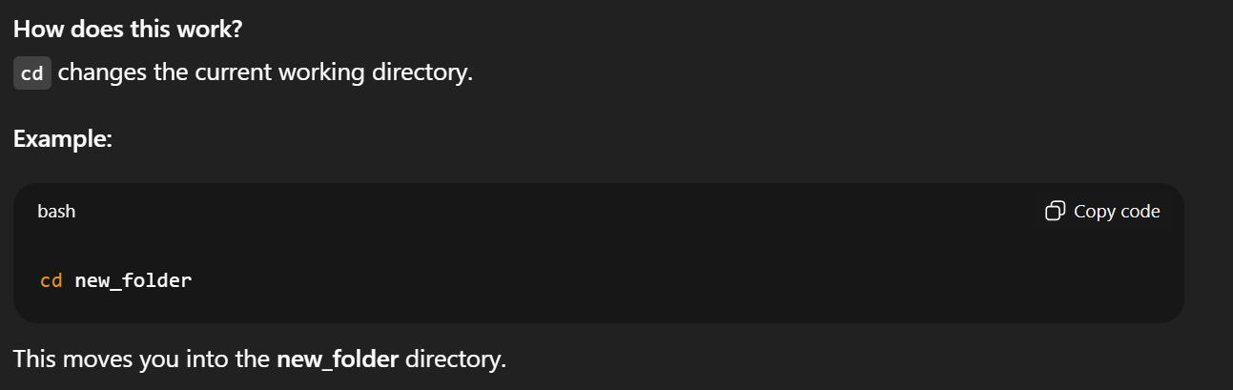
- Ls – list
- 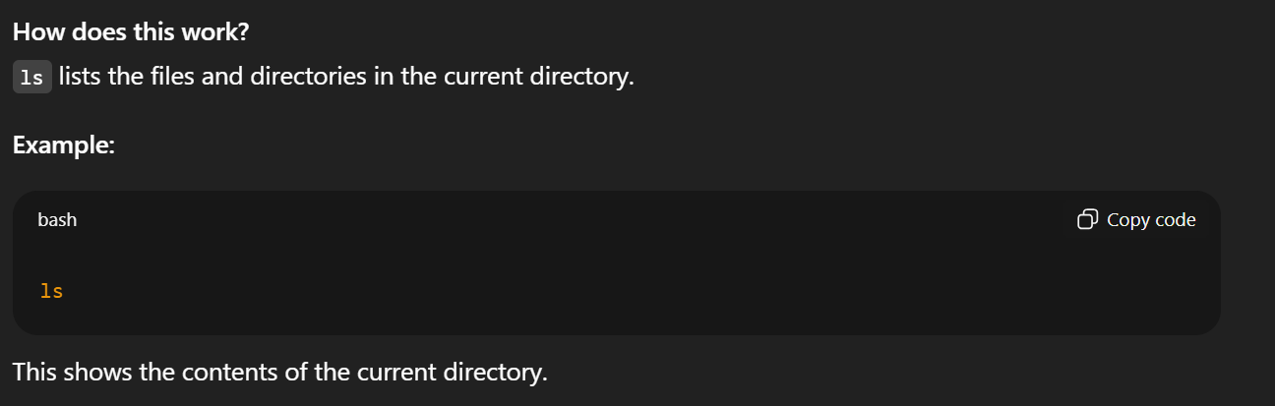
- Touch – creates a file
- 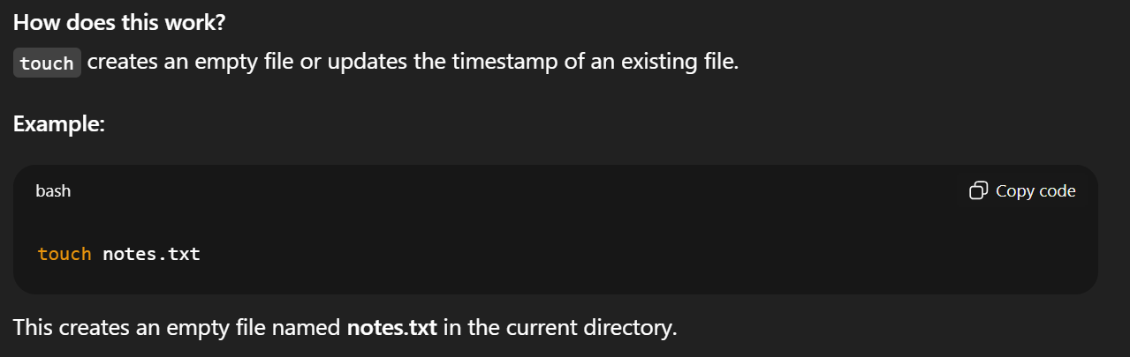
- Rm – removes files
- 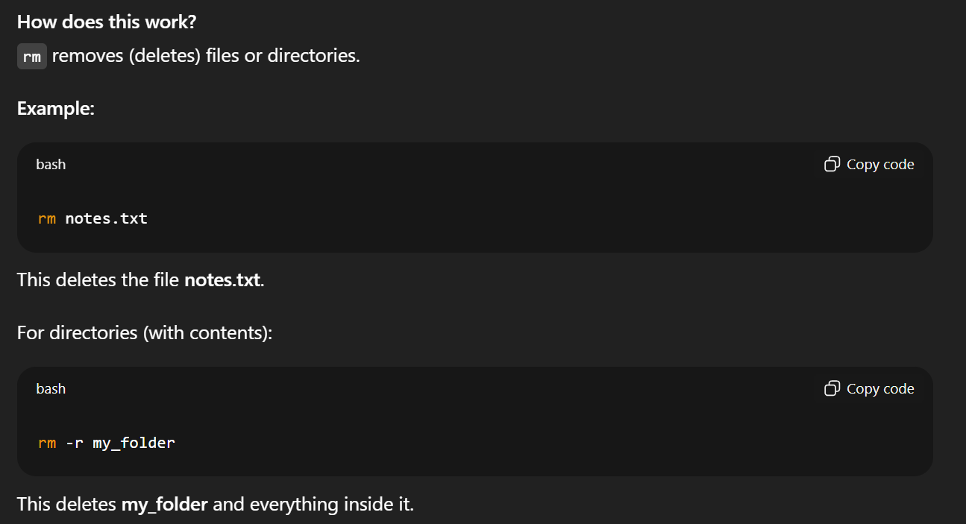
File Viewing and Editing
- Cat – concatenate and display
- 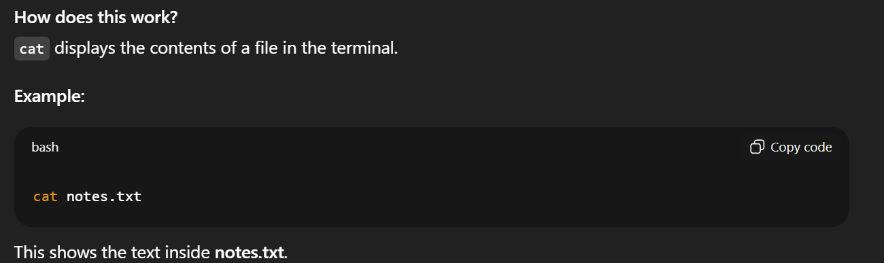
- echo – prints text or variables
- 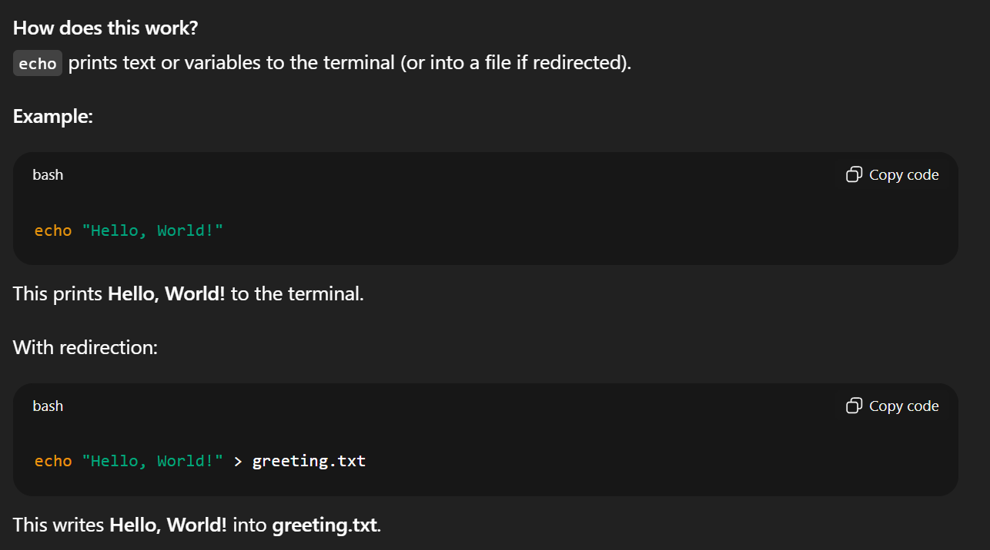
- > - overwrite file
- 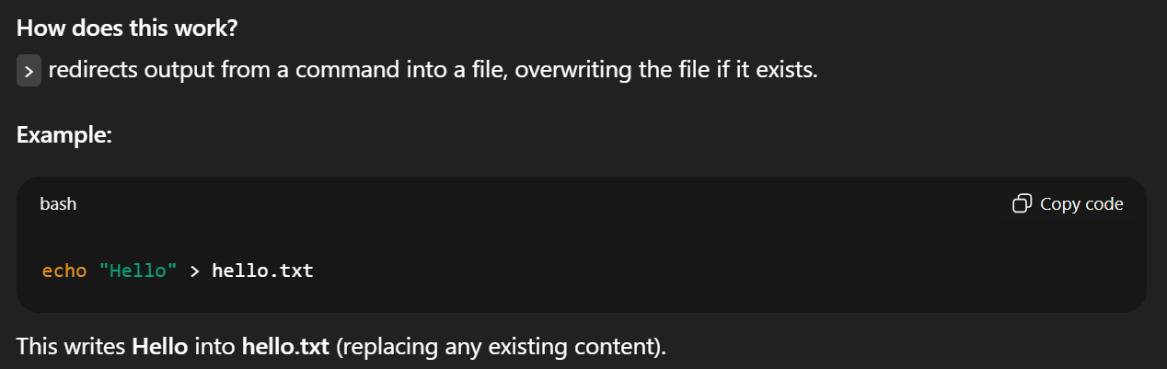
- >> - append to file
- 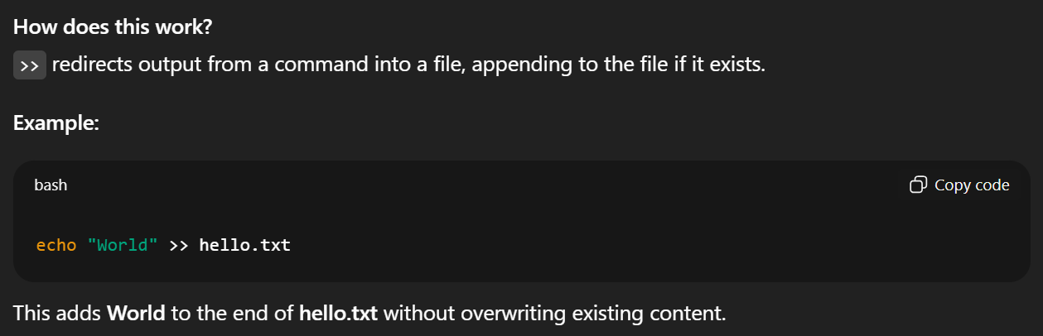
Searching
- grep "word" file – searches for “word” in file, displaying all lines where it occurs
- grep -i "word" file – same as above but case insensitive
- grep -E "regex" file – same as first but can use regex
- grep -n "word" file – shows line number of matches
- grep -E '[0-9]{4}-[0-9]{2}-[0-9]{2}' file.txt – YYYY/MM/DD in file.txt
- grep -E '[0-9]{3}-[0-9]{3}-[0-9]{4}' file.txt – phone number in file.txt
- grep -E '[A-Z][0-9][A-Z] ?[0-9][A-Z][0-9]' file.txt – Canadian postal codes in file.txt
- 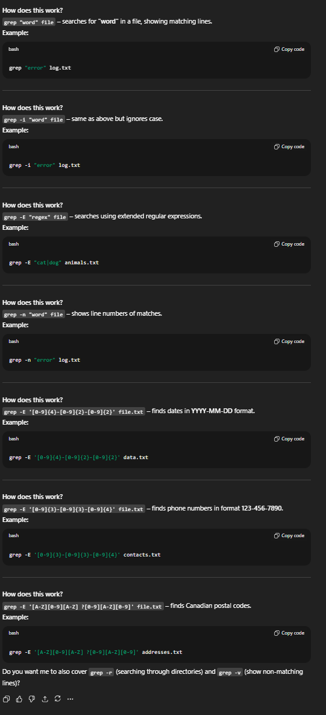
Archiving
- tar -czf archive.tar.gz file – compresses file into archive.tar.gz
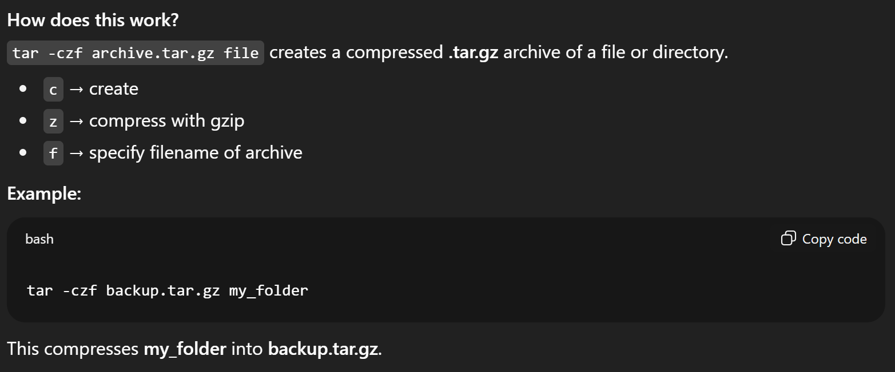
Running Scripts
- chmod +x organizer.sh – makes organizer.sh excecutable
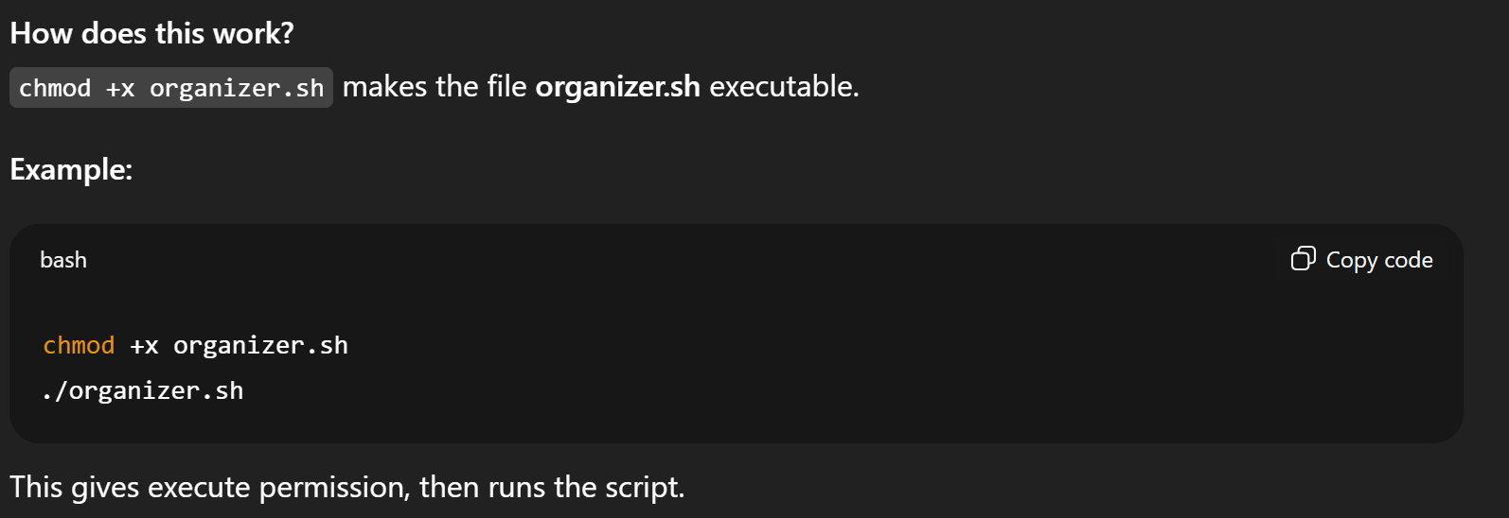
- ./organizer.sh – runs the script
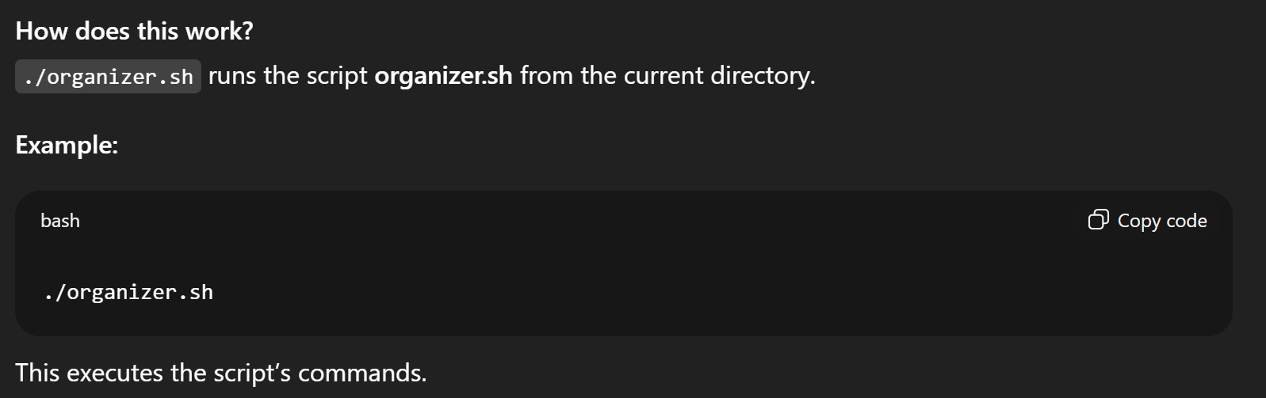
- bash organizer.sh – runs script in bash shell
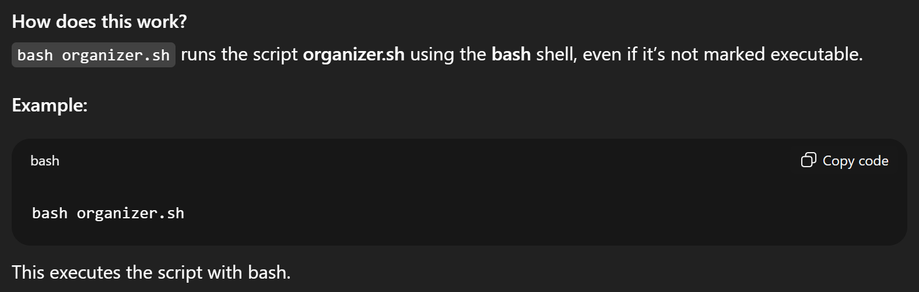
Terminal Management
- clear – clear terminal
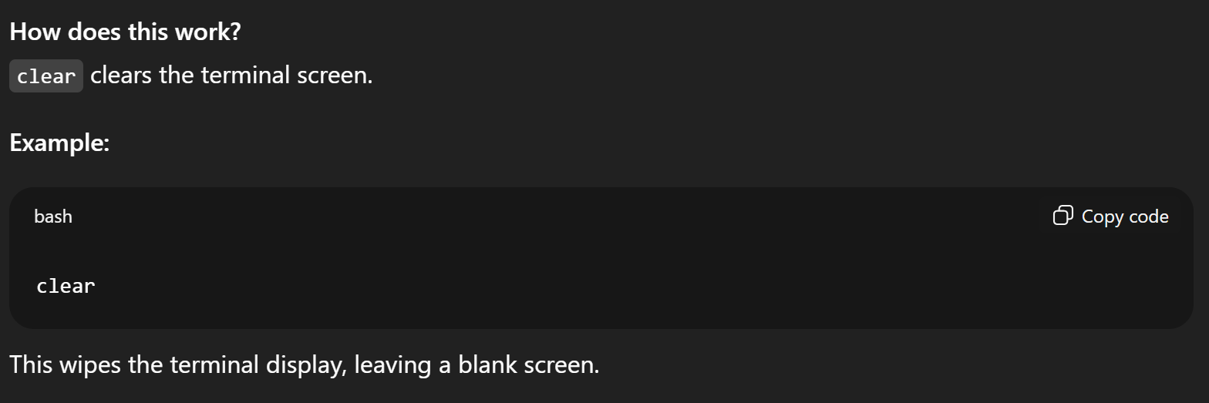

Bash Keywords and Script Structures to Explore
- variable=value – variable assignment
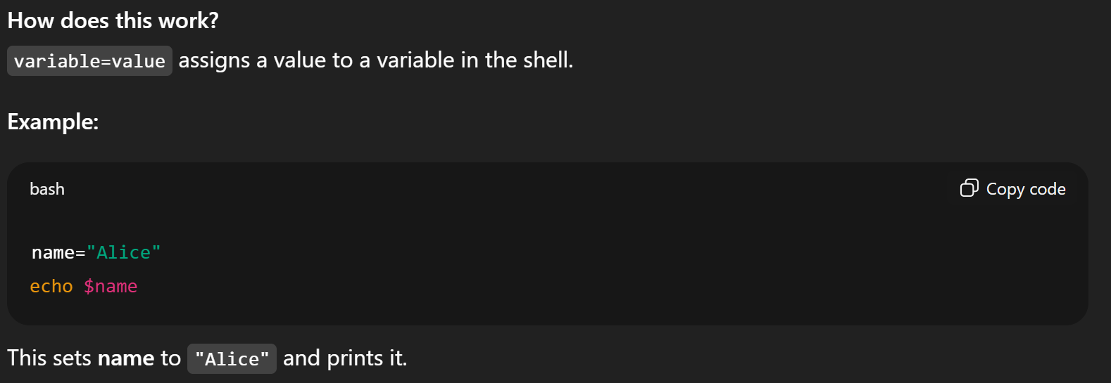
- read variable – get user input
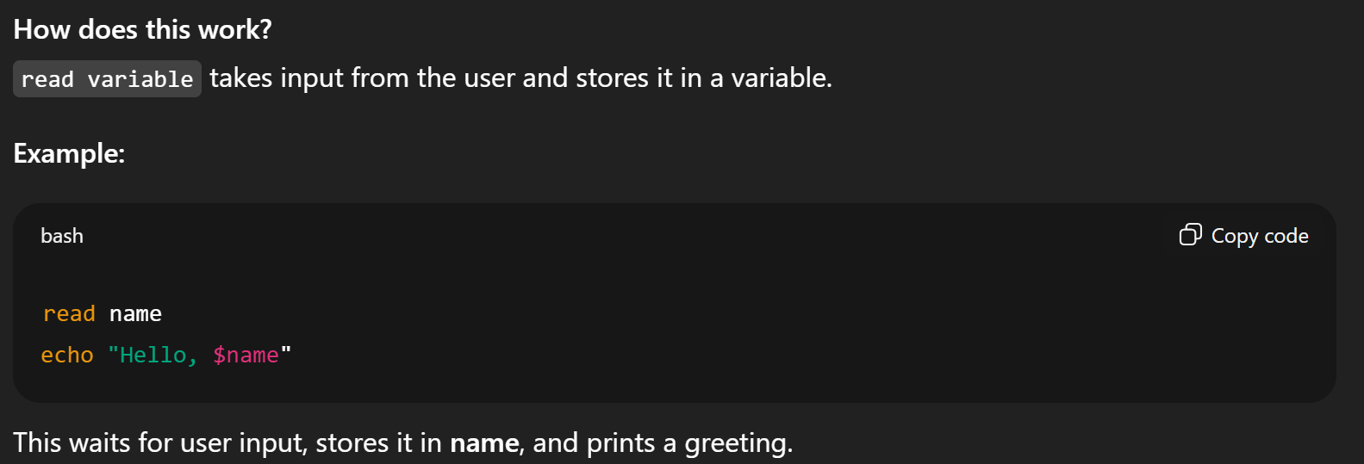
- $variable – access the variable
- 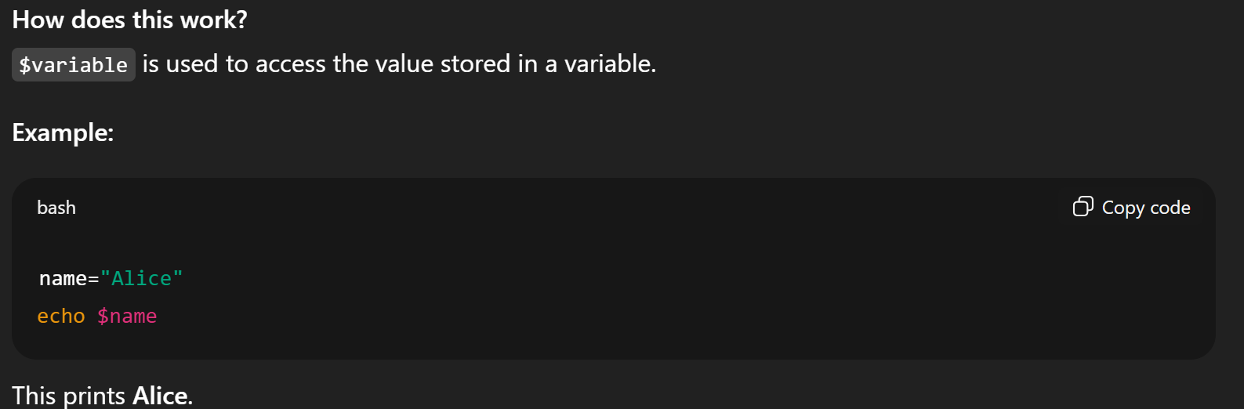
- if [ -f file ]; then ... fi – if file exists
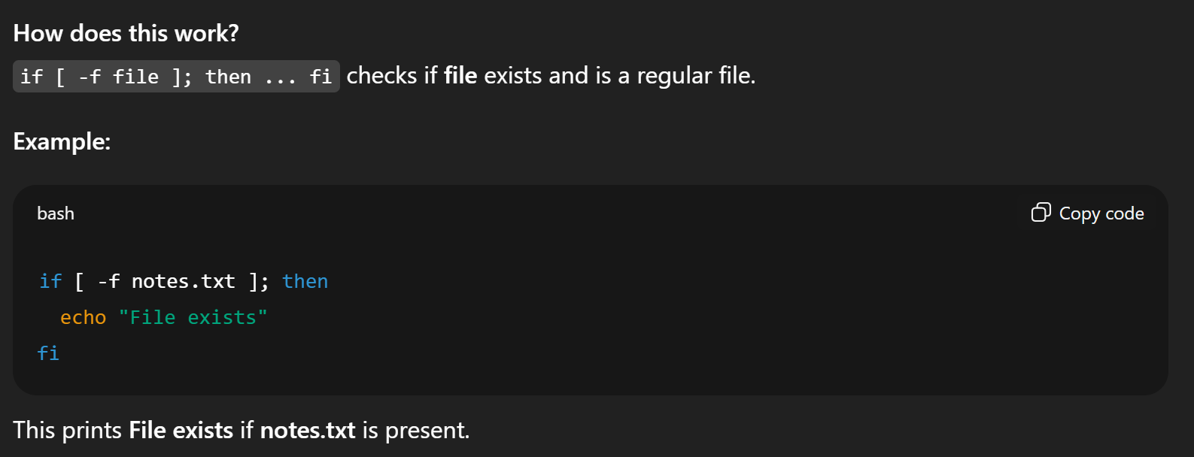
- if [ -d dir ]; then ... fi – if dir exists
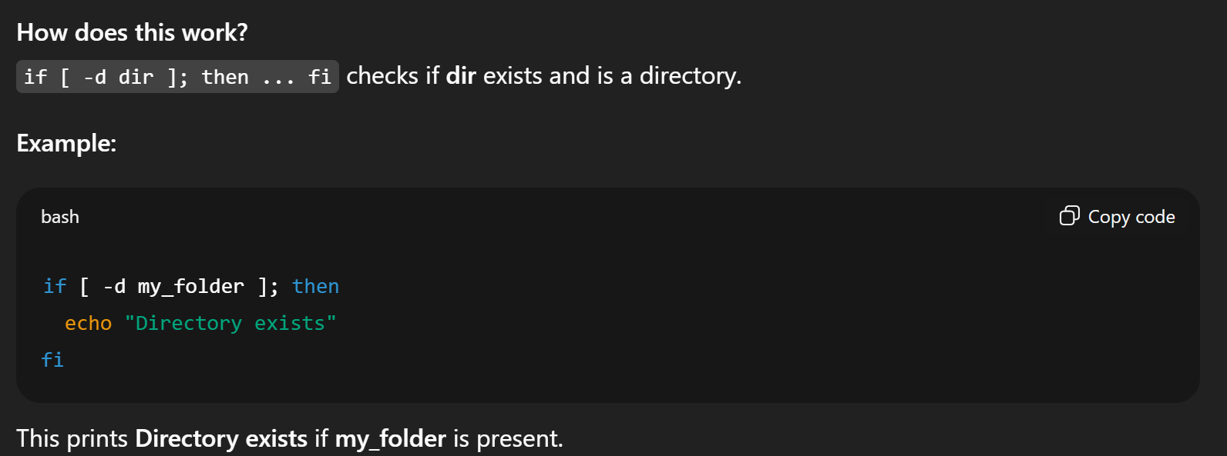
- if [ -z "$var" ]; then ... fi – if var is empty
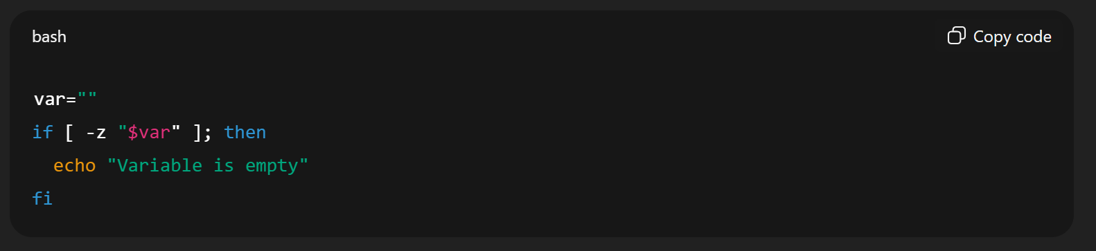
- while true; do ... done – while infinite loop
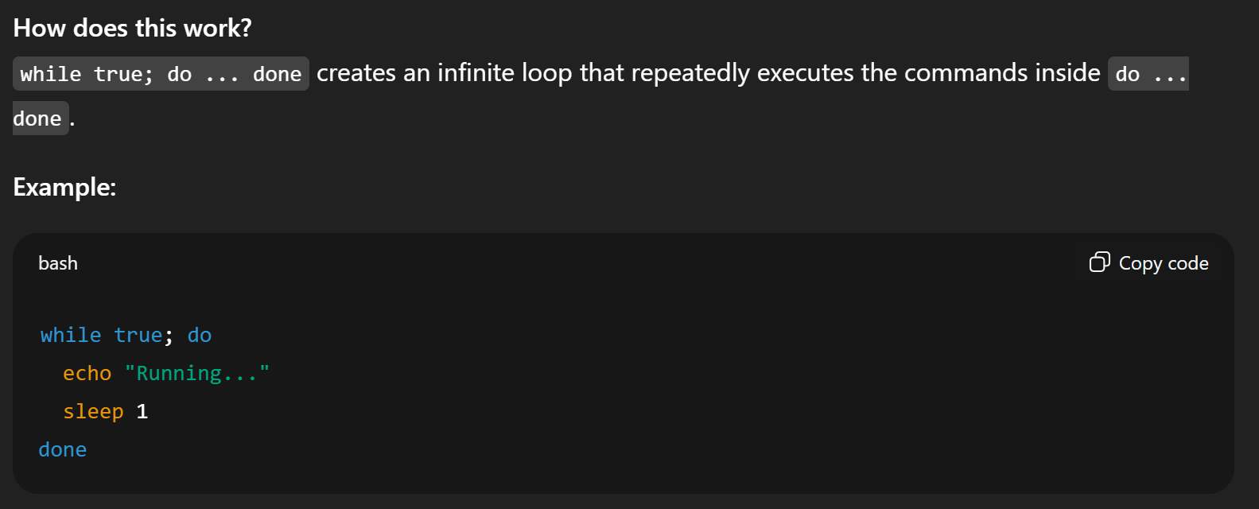
- case ... in ... esac – switch statement
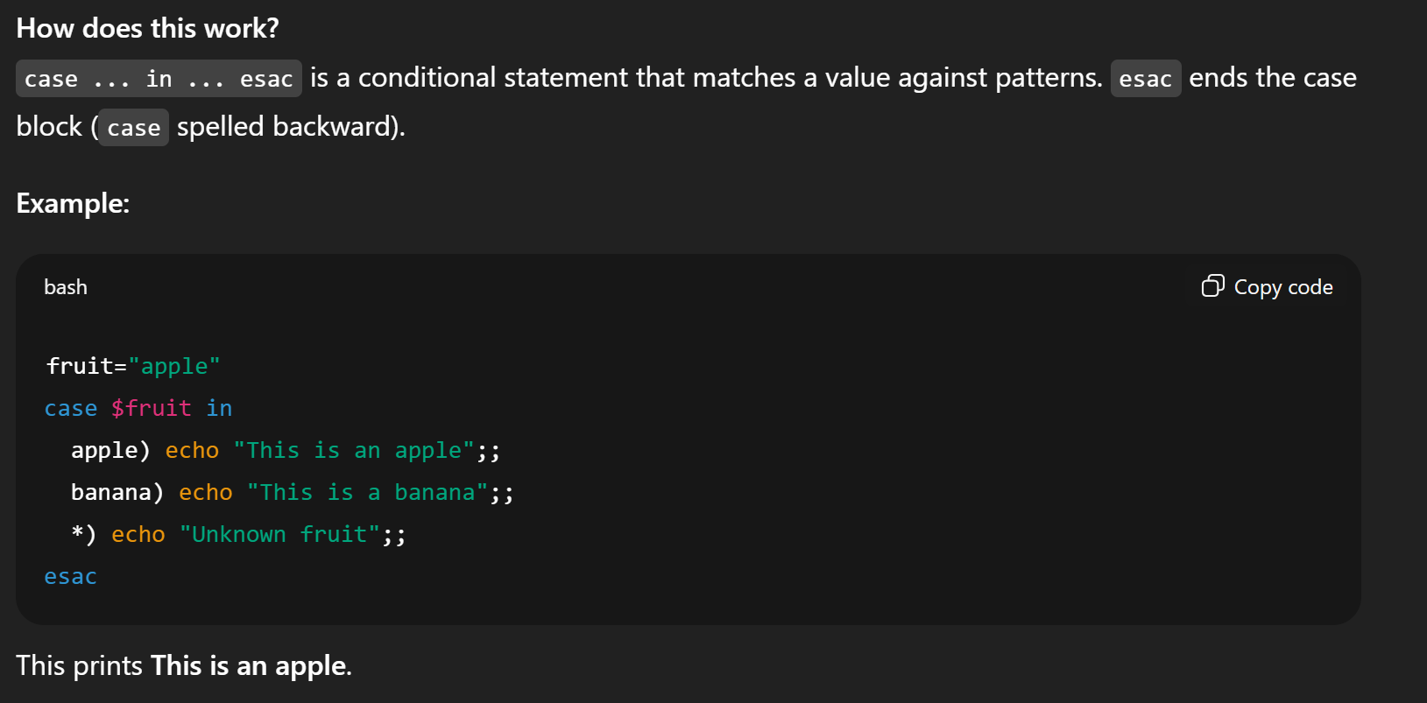
- exit – exit script
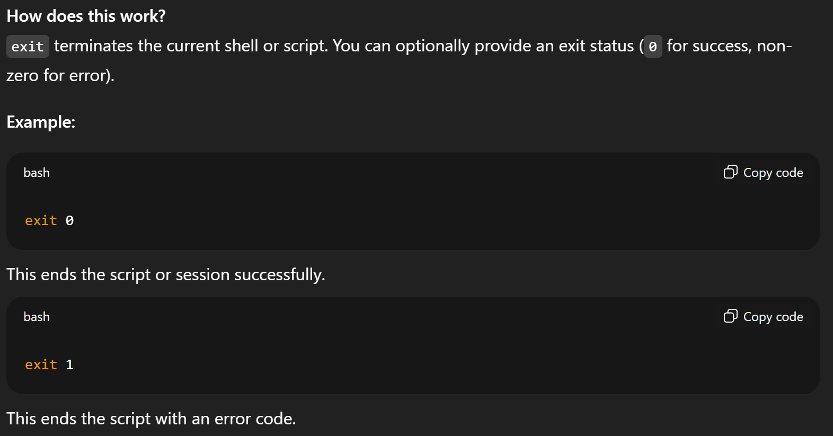
- #!/usr/bin/env bash – run using bash
